At Coulsdon Church of England Primary School, we follow the Kapow Primary RSE & PSHE curriculum. This document shows how knowledge, skills and attributes develop across the Kapow Primary RSE & PSHE curriculum from EYFS to Year 6. It demonstrates clear progression in statutory Relationships and Health Education (RHE) content, alongside wider PSHE learning, across key areas including My healthy self, Staying safe, The online world and Connecting with others.
Clear, specific statements are provided for both knowledge and skills. This reduces ambiguity, supports consistency in teaching and helps schools communicate transparently with parents and carers about what pupils learn and how understanding develops over time.
EYFS (Reception) content is mapped to the Self-regulation, Managing self and Building relationships strands of the EYFS Framework. These strands continue into Key Stage 1 and 2, with Critical thinking introduced in KS1, ensuring continuity and a smooth transition as pupils develop independence, emotional literacy and social understanding.
Teachers at Coulsdon Church of England Primary School use professional judgement when delivering content, recognising that sensitivity may vary depending on our school context and community.

Developing knowledge, skills and attributes in RSE & PSHE
The Kapow Primary RSE & PSHE scheme ensures full coverage of statutory RHE requirements from Year 1 to Year 6, alongside the EYFS Framework for Personal, Social and Emotional Development.
The curriculum is organised into clear key areas which structure learning and support meaningful progression. Knowledge is built through a spiral curriculum model, with key concepts revisited, deepened and applied over time. This supports long-term retention and helps pupils make connections across areas of learning.
Alongside subject knowledge, the curriculum develops four key strands that run throughout:
- Self-regulation
- Managing self
- Building relationships
- Critical thinking
The first three strands are rooted in the EYFS Framework and extended through KS1 and KS2. Critical thinking is introduced to support pupils in questioning information, particularly online, and making informed, responsible decisions.
Together, these strands ensure pupils develop the knowledge, skills and dispositions needed to manage themselves, relate positively to others and engage thoughtfully with the world.

The strands
Self-regulation
Self-regulation is the ability to recognise and manage emotions, thoughts and behaviour. Pupils learn to understand their feelings, stay calm in challenging situations, resolve conflict respectfully and remain focused on tasks.
Managing self
Managing self involves taking responsibility for personal needs, choices and behaviour. This includes caring for physical and mental wellbeing, following rules, showing resilience and developing independence over time.
Building relationships
Building relationships focuses on forming positive, respectful connections with others. Pupils learn to communicate effectively, show empathy, build trust and establish and respect personal boundaries.
Critical thinking
Critical thinking is the ability to think independently and make well-informed decisions. Pupils learn to ask questions, consider different perspectives, evaluate information and recognise influence, particularly in online contexts.

How the RSE & PSHE curriculum is organised
The Kapow Primary RSE & PSHE curriculum is designed to support statutory guidance while also offering a broad and balanced PSHE education.
It draws on:
- Statutory Relationships and Health Education guidance
- Non-statutory guidance for online safety
- The Citizenship programmes of study for Key Stages 1 and 2
Content is organised into recurring key areas, which are revisited each year. This whole-school approach supports consistency, progression and opportunities for shared themes, assemblies and events.
The key areas are:
- My healthy self*
- Connecting with others*
- The online world*
- Staying safe*
- Health protection*
- Growing up*
- Citizenship
- First aid (Year 6 optional)
- Sex education (Year 6 optional)
*Indicates areas that support statutory RHE requirements.
Returning to these areas each year ensures full coverage while allowing learning to deepen as pupils’ understanding, maturity and independence grow.

Exploring the key areas
The four core key areas — My healthy self, Connecting with others, The online world and Staying safe — are taught every year. This allows pupils across the school to focus on similar themes at the same time, supporting whole-school planning and reinforcement.
While there is natural overlap between areas, organising learning in this way provides a clear structure and helps pupils make connections between knowledge, skills and real-life contexts.
Additional statutory areas (Health protection and Growing up) and optional units (Citizenship, First aid and Sex education) further broaden and strengthen the curriculum.

Key area summaries
My healthy self (Statutory)
This area supports pupils to understand and care for their mental and physical health. Pupils learn to recognise emotions, develop emotional literacy, understand mental wellbeing and make choices that support a healthy lifestyle, including sleep, nutrition and physical activity.
Connecting with others (Statutory)
Pupils learn about building and maintaining positive relationships with friends, family and others. This includes communication skills, empathy, boundaries, conflict resolution and recognising healthy and unhealthy relationships.
The online world (Statutory)
This area helps pupils recognise when they are online, understand online risks and use digital spaces safely and positively. Pupils learn to be critical consumers of information and to manage their interactions responsibly.
Staying safe (Statutory)
Pupils learn to recognise physical, emotional and social risks and how to respond. This includes understanding unsafe situations, recognising warning signs in relationships and knowing how and when to seek help.
Health protection (Statutory)
These units focus on keeping safe and healthy, including hygiene, illness prevention, emergency situations and basic first aid knowledge.
Growing up (Statutory)
Pupils learn about physical and emotional development, including puberty and the changes associated with growing older. In KS1, this focuses on independence and managing needs; in later years, it supports preparation for transition.
Citizenship (Non-statutory)
Citizenship units prepare pupils to be active members of society. Pupils learn about communities, rights and responsibilities, money management, careers and how choices can affect themselves and others.
First aid (Optional, Year 6)
This unit develops pupils’ understanding of how to respond in emergency situations and manage basic injuries.
Sex education (Optional, Year 6)
Where taught, this unit builds on statutory learning from Growing up and supports pupils’ understanding of human reproduction in an age-appropriate way.
Progression of skills
The skills progression outlines how pupils develop personal and social skills from EYFS through to the end of Key Stage 2. These skills are organised into four strands which run consistently throughout the curriculum.
The tables that follow show how expectations increase over time, moving from supported and emerging behaviours in EYFS to increasingly independent, reflective and mature application of skills in Upper Key Stage 2.

Self-regulation
Self-regulation focuses on pupils’ ability to recognise, understand and manage their emotions, thoughts and behaviour. Progression reflects pupils becoming more aware of their emotional responses, using strategies to stay calm and making thoughtful choices in increasingly complex situations.
The table below shows how self-regulation skills develop from EYFS to Upper Key Stage 2.
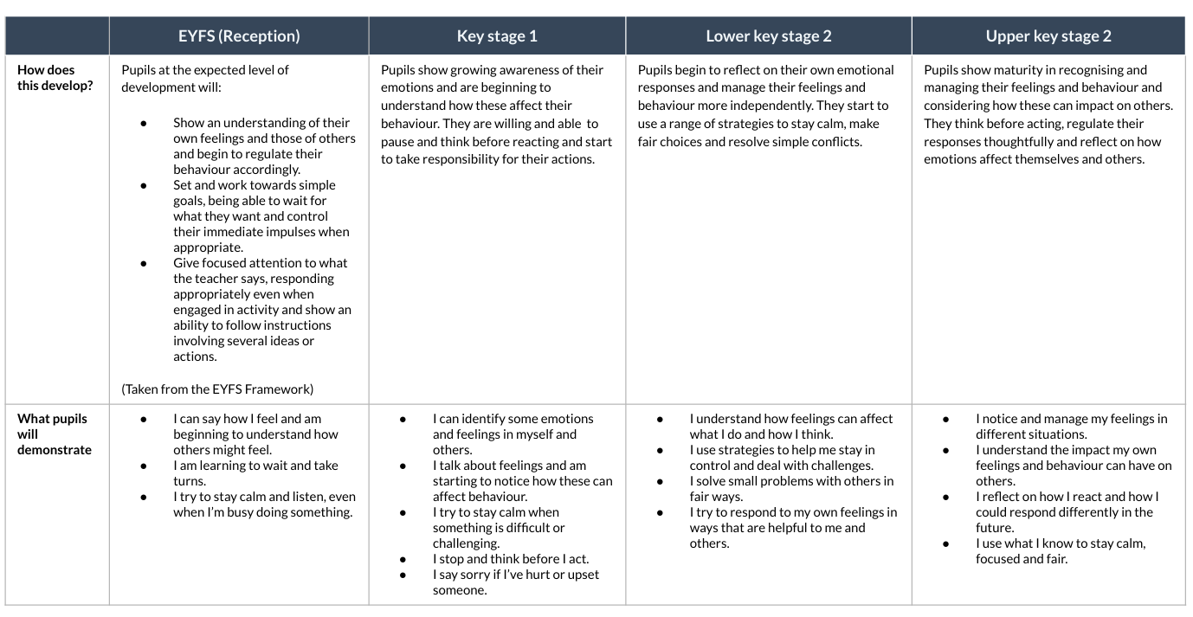

Managing self
Managing self refers to pupils taking increasing responsibility for their personal needs, routines, choices and behaviour. Over time, pupils develop independence, resilience and an understanding of how rules and routines support wellbeing and safety.
The table below shows how managing self skills progress across the primary years.
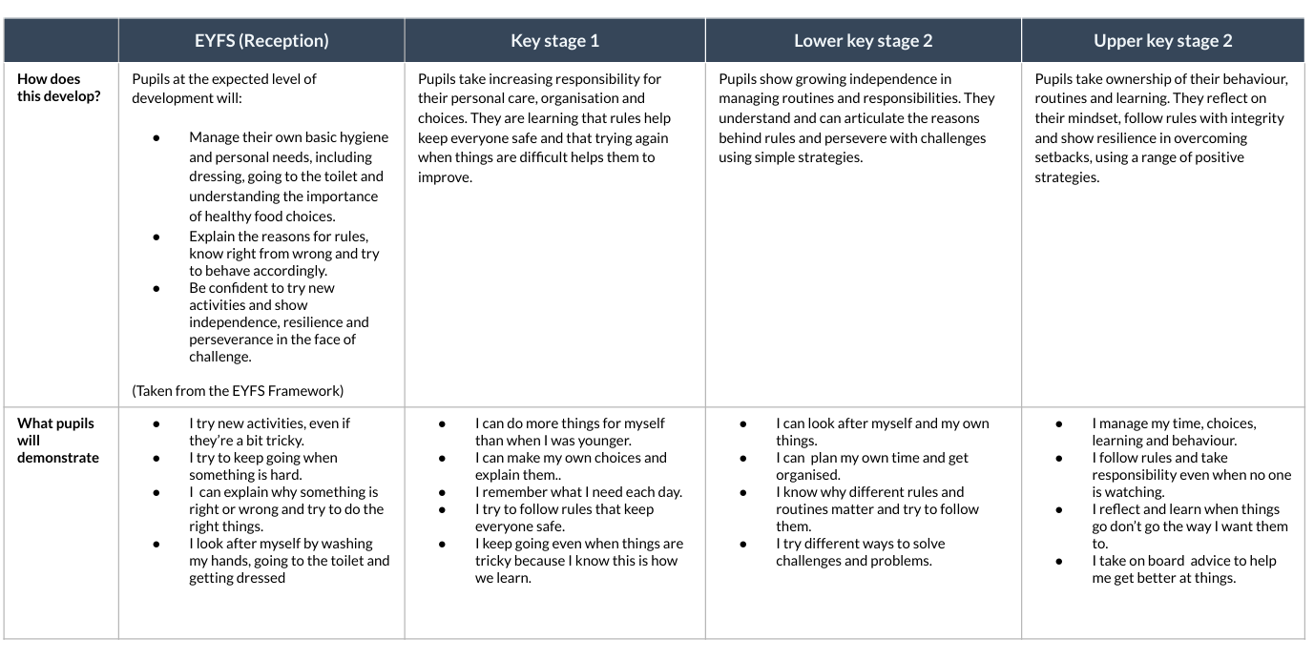

Building relationships
This strand focuses on how pupils form, maintain and repair relationships. Progression includes developing empathy, communication skills, respect for boundaries and the ability to manage conflict in fair and respectful ways.
The table below shows how relationship skills develop and deepen from EYFS to Upper Key Stage 2.
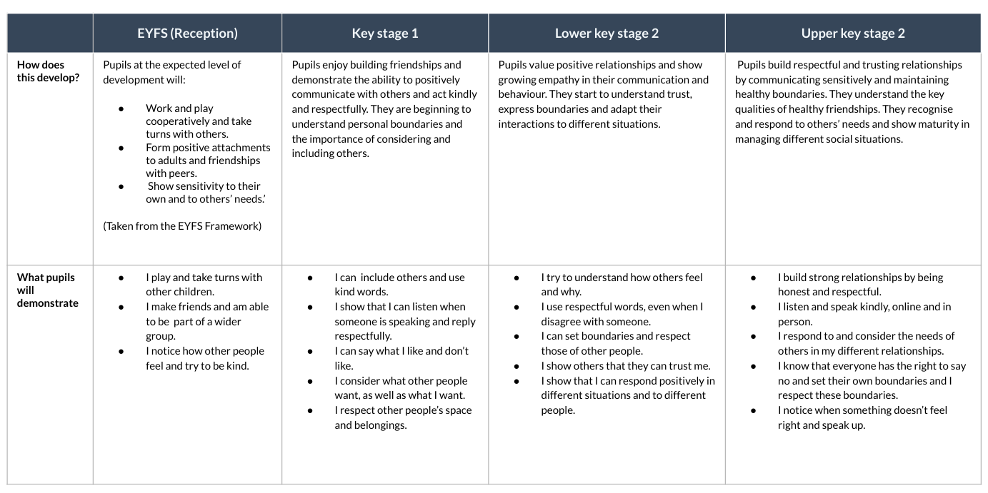

Critical thinking
Critical thinking supports pupils to question, reflect and make informed decisions. As pupils move through the school, they develop greater independence in evaluating information, recognising influence and considering different viewpoints.
The table below shows how critical thinking skills progress across the primary years.
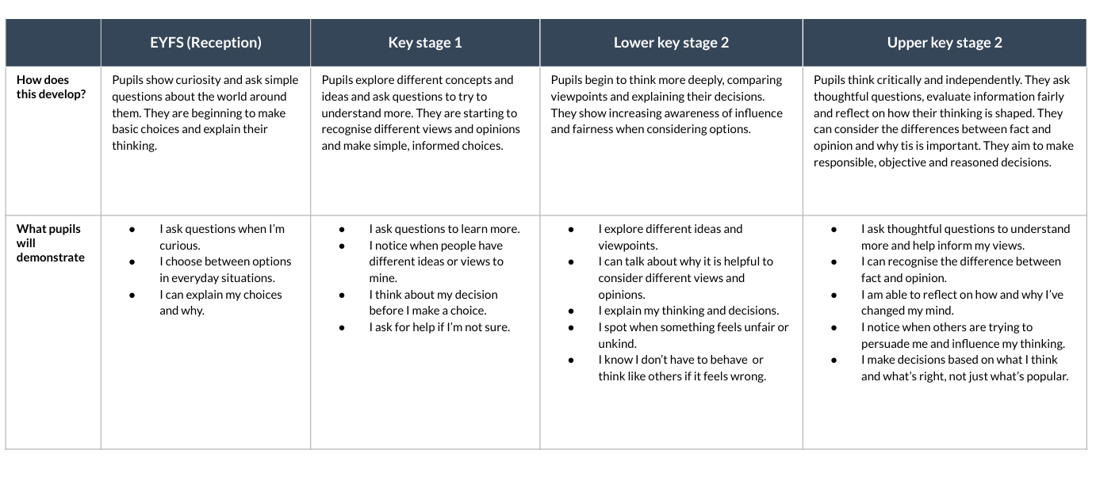

Progression of knowledge and understanding
The knowledge progression sets out what pupils are taught within each key area and how understanding builds from Year 1 to Year 6. Content is carefully sequenced to ensure statutory coverage while allowing pupils to revisit and deepen key concepts over time.
My healthy self
This key area develops pupils’ understanding of mental and physical wellbeing. Knowledge progression supports pupils to recognise emotions, understand mental health, develop self-care strategies and make informed choices that support a healthy lifestyle.
Recognising and talking about emotions
Pupils begin by identifying and naming basic emotions and associated feelings in themselves and others. As they progress through the school, they develop a wider emotional vocabulary, greater awareness of emotional intensity and an increasing ability to reflect on how emotions influence thoughts, behaviour and decision-making.
Progression supports pupils to communicate emotions clearly and respectfully, regulate responses and understand that people may experience and express emotions differently.
Mental wellbeing and support
Pupils learn that mental wellbeing is an important part of overall health. Early learning focuses on recognising when support is needed and identifying trusted adults. As pupils get older, they develop a clearer understanding of mental health, recognise signs that someone may need help and learn how and where to seek appropriate support.
This progression normalises seeking help and reinforces that early support can make a positive difference.
Self-care and emotional wellbeing
This area develops pupils’ understanding of how everyday habits support emotional wellbeing. Pupils explore strategies such as rest, play, relationships, time outdoors and sleep, and reflect on which strategies work best for them in different situations.
Over time, pupils learn to take greater responsibility for their own wellbeing and to recognise how their actions can support both themselves and others.
Physical health and active lifestyles
Pupils develop an understanding of why physical activity is important for both physical and mental health. Learning progresses from recognising active behaviours to understanding the benefits of regular activity and the risks associated with inactivity.
Pupils are supported to make informed choices about movement, exercise and lifestyle habits as they grow older.

Healthy eating and dental health
Knowledge progression supports pupils to make healthy food choices, understand balanced diets and develop a positive relationship with food. Pupils also learn how to care for their teeth and understand the importance of good oral hygiene.
As pupils progress, they become more critical of food choices, recognising influences such as advertising and understanding long-term health implications.
Bullying and wellbeing
Pupils learn about the impact of bullying on emotional and mental wellbeing. Progression supports pupils to develop empathy, understand the short- and long-term effects of bullying and recognise when support is needed.
Connecting with others
This key area develops pupils’ understanding of relationships with family, friends and others. Knowledge progression focuses on communication, empathy, respect, boundaries and managing conflict.
Pupils learn that healthy relationships are built on trust, kindness, respect and mutual understanding, and that support is available when relationships feel unsafe or unhealthy.
Families and people who care for us
Pupils learn that families can take many forms and that caring relationships are built on love, trust and support. Progression helps pupils recognise who cares for them, how families support wellbeing and that family structures may differ.
As pupils get older, they develop greater understanding of change within families and how to seek support when family circumstances are challenging.

Friendships
Pupils explore what makes a good friend, including kindness, honesty, sharing and cooperation. Progression supports pupils to recognise positive and negative behaviours in friendships and to respond appropriately.
Older pupils learn how friendships can change, how to manage peer pressure and how to seek help when friendships feel unbalanced or unsafe.

Communication and empathy
This area develops pupils’ ability to communicate thoughts and feelings clearly and to listen to others. Progression focuses on understanding different perspectives, showing empathy and responding respectfully in a range of situations.
As pupils mature, they learn to communicate more confidently and sensitively, particularly during disagreement or conflict.

Boundaries, consent and personal space
Pupils learn about personal boundaries, body autonomy and the importance of respecting their own and others’ space. Early learning focuses on simple boundaries and permission.
Over time, pupils develop a clearer understanding of consent, privacy and how to respond if boundaries are crossed.

Managing conflict and resolving problems
Pupils learn strategies for resolving conflict calmly and fairly. Progression supports pupils to move from adult-supported problem-solving to independently managing disagreements, recognising when to compromise and when to seek help.

The online world
This key area supports pupils to understand how digital technologies affect everyday life. Knowledge progression focuses on safe, respectful and responsible online behaviour.
Pupils develop the skills needed to navigate online spaces confidently, recognise risk and make informed decisions.
Online identity and behaviour
Pupils learn that people may present themselves differently online and that online actions can have real-world consequences. Progression supports pupils to reflect on their own online behaviour and to understand how respectful, kind behaviour applies both online and offline.
As pupils get older, they consider how digital footprints are created and how choices online can affect reputation and wellbeing.

Staying safe online
Pupils learn how to stay safe when using digital technologies. Early learning focuses on recognising trusted adults and knowing what to do if something online feels worrying.
Over time, pupils develop a clearer understanding of online risks, including contact, content and conduct, and learn strategies for managing these safely and confidently.

Online relationships and communication
This area supports pupils to understand how people interact online. Pupils learn to recognise respectful and disrespectful communication and understand that boundaries apply online as well as offline.
Progression supports pupils to manage online interactions responsibly and to seek support when communication feels unsafe or upsetting.

Information, influence and media literacy
Pupils learn that not all information online is accurate or reliable. Progression develops pupils’ ability to question sources, recognise persuasion and understand how content can be designed to influence behaviour and opinions.
Older pupils apply critical thinking skills to evaluate information and make informed choices about what they view, share and trust.

Staying safe
This key area supports pupils to recognise risk, understand personal safety and know how to respond to unsafe situations. Knowledge progression focuses on developing awareness, confidence and appropriate help-seeking behaviours.
Pupils learn that they have the right to feel safe and that support is available when they are worried or unsure.

Recognising risk and unsafe situations
Pupils learn to recognise situations that may pose a risk to their safety, both online and offline. Early learning focuses on identifying unsafe situations and understanding that feeling worried or uncomfortable is a sign to seek help.
As pupils progress, they develop a more nuanced understanding of risk, including social, emotional and environmental risks, and learn to assess situations more independently.

Seeking help and trusted adults
Pupils learn who they can turn to for help and how to ask for support. Progression supports pupils to identify trusted adults in different contexts and understand that it is always appropriate to ask for help when something feels wrong.
Older pupils learn how to access wider sources of support and develop confidence in speaking up for themselves and others.

Personal safety and boundaries
This area reinforces pupils’ understanding of personal boundaries and safety. Pupils learn that their body belongs to them and that they have the right to say no and to be listened to.
As pupils mature, they develop greater awareness of how to protect themselves and others, recognise unsafe behaviour and know how to respond appropriately.

Responding to emergencies and unsafe situations
Pupils learn simple strategies for responding to unsafe situations, including staying calm, getting help and knowing emergency procedures. Progression supports pupils to act more confidently and responsibly in challenging situations.

Health protection
This key area focuses on keeping physically healthy and preventing illness. Knowledge progression supports pupils to understand how everyday actions contribute to health and safety, and how to respond when health is at risk.
Hygiene and preventing illness
Pupils learn about personal hygiene and routines that help prevent the spread of illness. Early learning focuses on simple habits such as handwashing.
As pupils progress, they develop a clearer understanding of germs, infection and the importance of maintaining good hygiene in different contexts.

Managing illness and basic health needs
Pupils learn how to manage common illnesses and understand when rest, care or medical support may be needed. Progression supports pupils to recognise symptoms and communicate how they are feeling.
Older pupils learn how to take greater responsibility for managing their own health needs.

Medicines and substances
Pupils learn that medicines can be helpful when used correctly and harmful if misused. Progression supports pupils to understand safety rules around medicines and substances and the importance of following adult guidance.

Emergency situations and basic first aid awareness
Pupils develop awareness of how to respond in emergency situations. Early learning focuses on knowing how to get help.
As pupils progress, they gain a clearer understanding of emergency responses and how their actions can help keep themselves and others safe.

Growing up
This key area supports pupils’ understanding of physical and emotional development as they grow older. Knowledge progression is carefully sequenced to ensure learning is age-appropriate, inclusive and sensitive.
Growing and changing
Pupils learn that people grow and change over time. Early learning focuses on changes from babyhood to childhood and developing independence.
As pupils progress, they develop a clearer understanding of physical and emotional changes associated with growing older.

Puberty and physical development
Pupils learn about the physical changes that occur during puberty in an age-appropriate and factual way. Progression supports pupils to understand that puberty is a normal part of growing up and that everyone experiences it differently.
Learning is designed to build confidence, reduce anxiety and prepare pupils for future changes.

Emotional changes and wellbeing
Pupils learn that emotional changes can occur alongside physical development. Progression supports pupils to recognise and manage changing feelings, develop resilience and seek support when needed.

Preparing for transition
As pupils approach the end of primary school, learning supports them to prepare for change and transition. Pupils develop strategies to manage worries, ask questions and approach new situations with confidence.

